Baking Bad – Season 3 – Solving Equations
William “Billy” Black has branched out into to catering for events.
He asks just three questions of his customers:
- How many tables there are at the event?
- How many cakes are needed?
- Do you want any cakes put to one side?
The trouble is that he now needs to calculate how many cakes to leave on each table.
Can you help?
Event 1:
Number of tables: 6
Total cakes ordered: 48
Number of cakes put to one side: 0
Number of cakes required per table?
Event 2:
Number of tables: 10
Total cakes ordered: 53
Number of cakes put to one side: 3
Number of cakes required per table?
Event 3:
Number of tables: 5
Total cakes ordered: 58
Number of cakes put to one side: 13
Number of cakes required per table?
Event 4:
Number of tables: 9
Total cakes ordered: 91
Number of cakes put to one side: 19
Number of cakes required per table?
Event 5:
Number of tables: 15
Total cakes ordered: 110
Number of cakes put to one side: 20
Number of cakes required per table?
Event 6:
Number of tables: 4
Total cakes ordered: 36
Number of cakes put to one side per table: 2
Number of cakes required per table?
Event 7:
Number of tables: 6
Total cakes ordered: 54
Number of cakes put to one side per table: 3
Number of cakes required per table?
Event 8:
William “Billy Black” is catering two events today, but he’s lost some of the information about them. He knows that both events ordered the same number of cakes.
Event A has 6 tables and want 3 cakes left over.
Event B has 5 tables and want 8 cakes left over.
How many cakes need to go on each table?
Event 9:
William “Billy Black” is catering two events again, but yet again he’s lost some of the information. He knows that both events ordered the same number of cakes.
Event A has 8 tables and want 3 cakes left over.
Event B has 3 tables and want 18 cakes left over.
How many cakes need to go on each table?
Event 10:
William “Billy Black” is catering two events again, and old habits die hard as he loses yet more information. He knows that both events ordered the same number of cakes.
Event A has 7 tables and want 17 cakes left over.
Event B has 9 tables and want 3 cakes left over.
How many cakes need to go on each table?
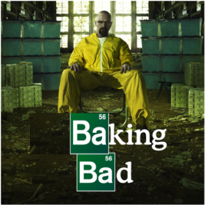
Season 3

