Baking Bad – Series 2 – Surface Area and Volume
William “Billy” Black has been a Food Technology teacher for years, won awards at local bake-offs and is well known for producing the best cakes in the local area. As a result he has been earmarked by visiting aliens to become their planet’s official chef. Billy has therefore decided to sell his wares to provide for his family when he’s gone…
Can you help William “Billy” Black calculate the following:
- The volume of his cake tins to he knows how much cake mixture is required for each?
- The surface area of his cake tins so that he knows how much non-stick baking paper is required to prevent his cakes sticking?
Cake Tin 1:
This cake tin is a square-based cuboid.
The length of each side of the tin is 25cm.
The height of the tin is 8cm.

Cake Tin 2:
This cake tin is a rectangular-based cuboid.
The length of the tin is 35cm.
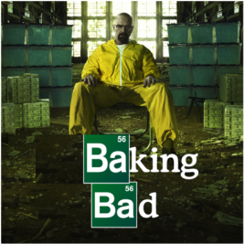
The width of the tin is 20cm.
The height of the tin is 4cm.

Cake Tin 3:
This cake tin is a cylinder.
The diameter of the tin is 20cm.
The height of the tin is 12cm.

Cake Tin 4:
Surface area of a sphere:
$$4{πr}^{2}$$
Volume of a sphere:
$$\frac{4}{3}{πr}^{3}$$
This cake tin is a hemisphere.
The diameter of the tin is 24cm.

Cake Tin 5:
Each section of this cake tin is a circular-based frustum.
Volume of a cone:
$$\frac{1}{3}{πr}^{2}h$$
The radius at the top of each section is 6cm.
Curved surface area of a cone:
$$πrl$$
The radius at the bottom of each section is 3cm.
The depth of each section is 4cm.

