Batman’s Bearings
Give the direction and bearing upon which Batman has to travel and use the scale to calculate how far he has gone whilst catching all the criminals.
Note: all directions are North, North East, East, South East, South, South West, West or North West.
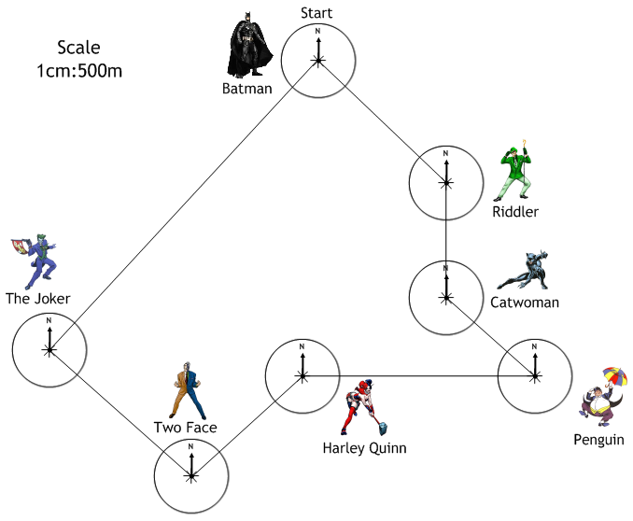
From | To | Direction | Bearing | Distance (m)
Start | Riddler
Riddler | Catwoman
Catwoman | Penguin
Penguin | Harley Quinn
Harley Quinn | Two Face
Two Face | The Joker
The Joker | Finish

