This game can be used to practice just about any skill. I have been amazed at how parents and teachers have adapted this concept in teaching Math, Science and other subjects. Let me show you how to practice math with this game. It is a simple, yet highly effect teaching and practising tool for teachers and learners.
Before you play – Read this!
- You need dice with 6 sides. Each side must have a number. Numbers could be 1, 2,3,4, 5 or 6.
- You need round chips of different colors.
- Your children should know how to count from 1 to 6.
- Choose the sound or grapheme cards you want to use for practice and use for playing.
- Use your free account to print out more cards from our site if you need. For example, if you want to practice addition for kindergarten, print out the set of cards from our websites cards or board games section. You can even make your own cards for just about any topic.
- Shuffle the cards and place them face down (so as not to show the problems)
- You need at least 2 players or 2 teams to play. Each team can contain any number of students as long as they are taking turns, you should be good.
Game Story
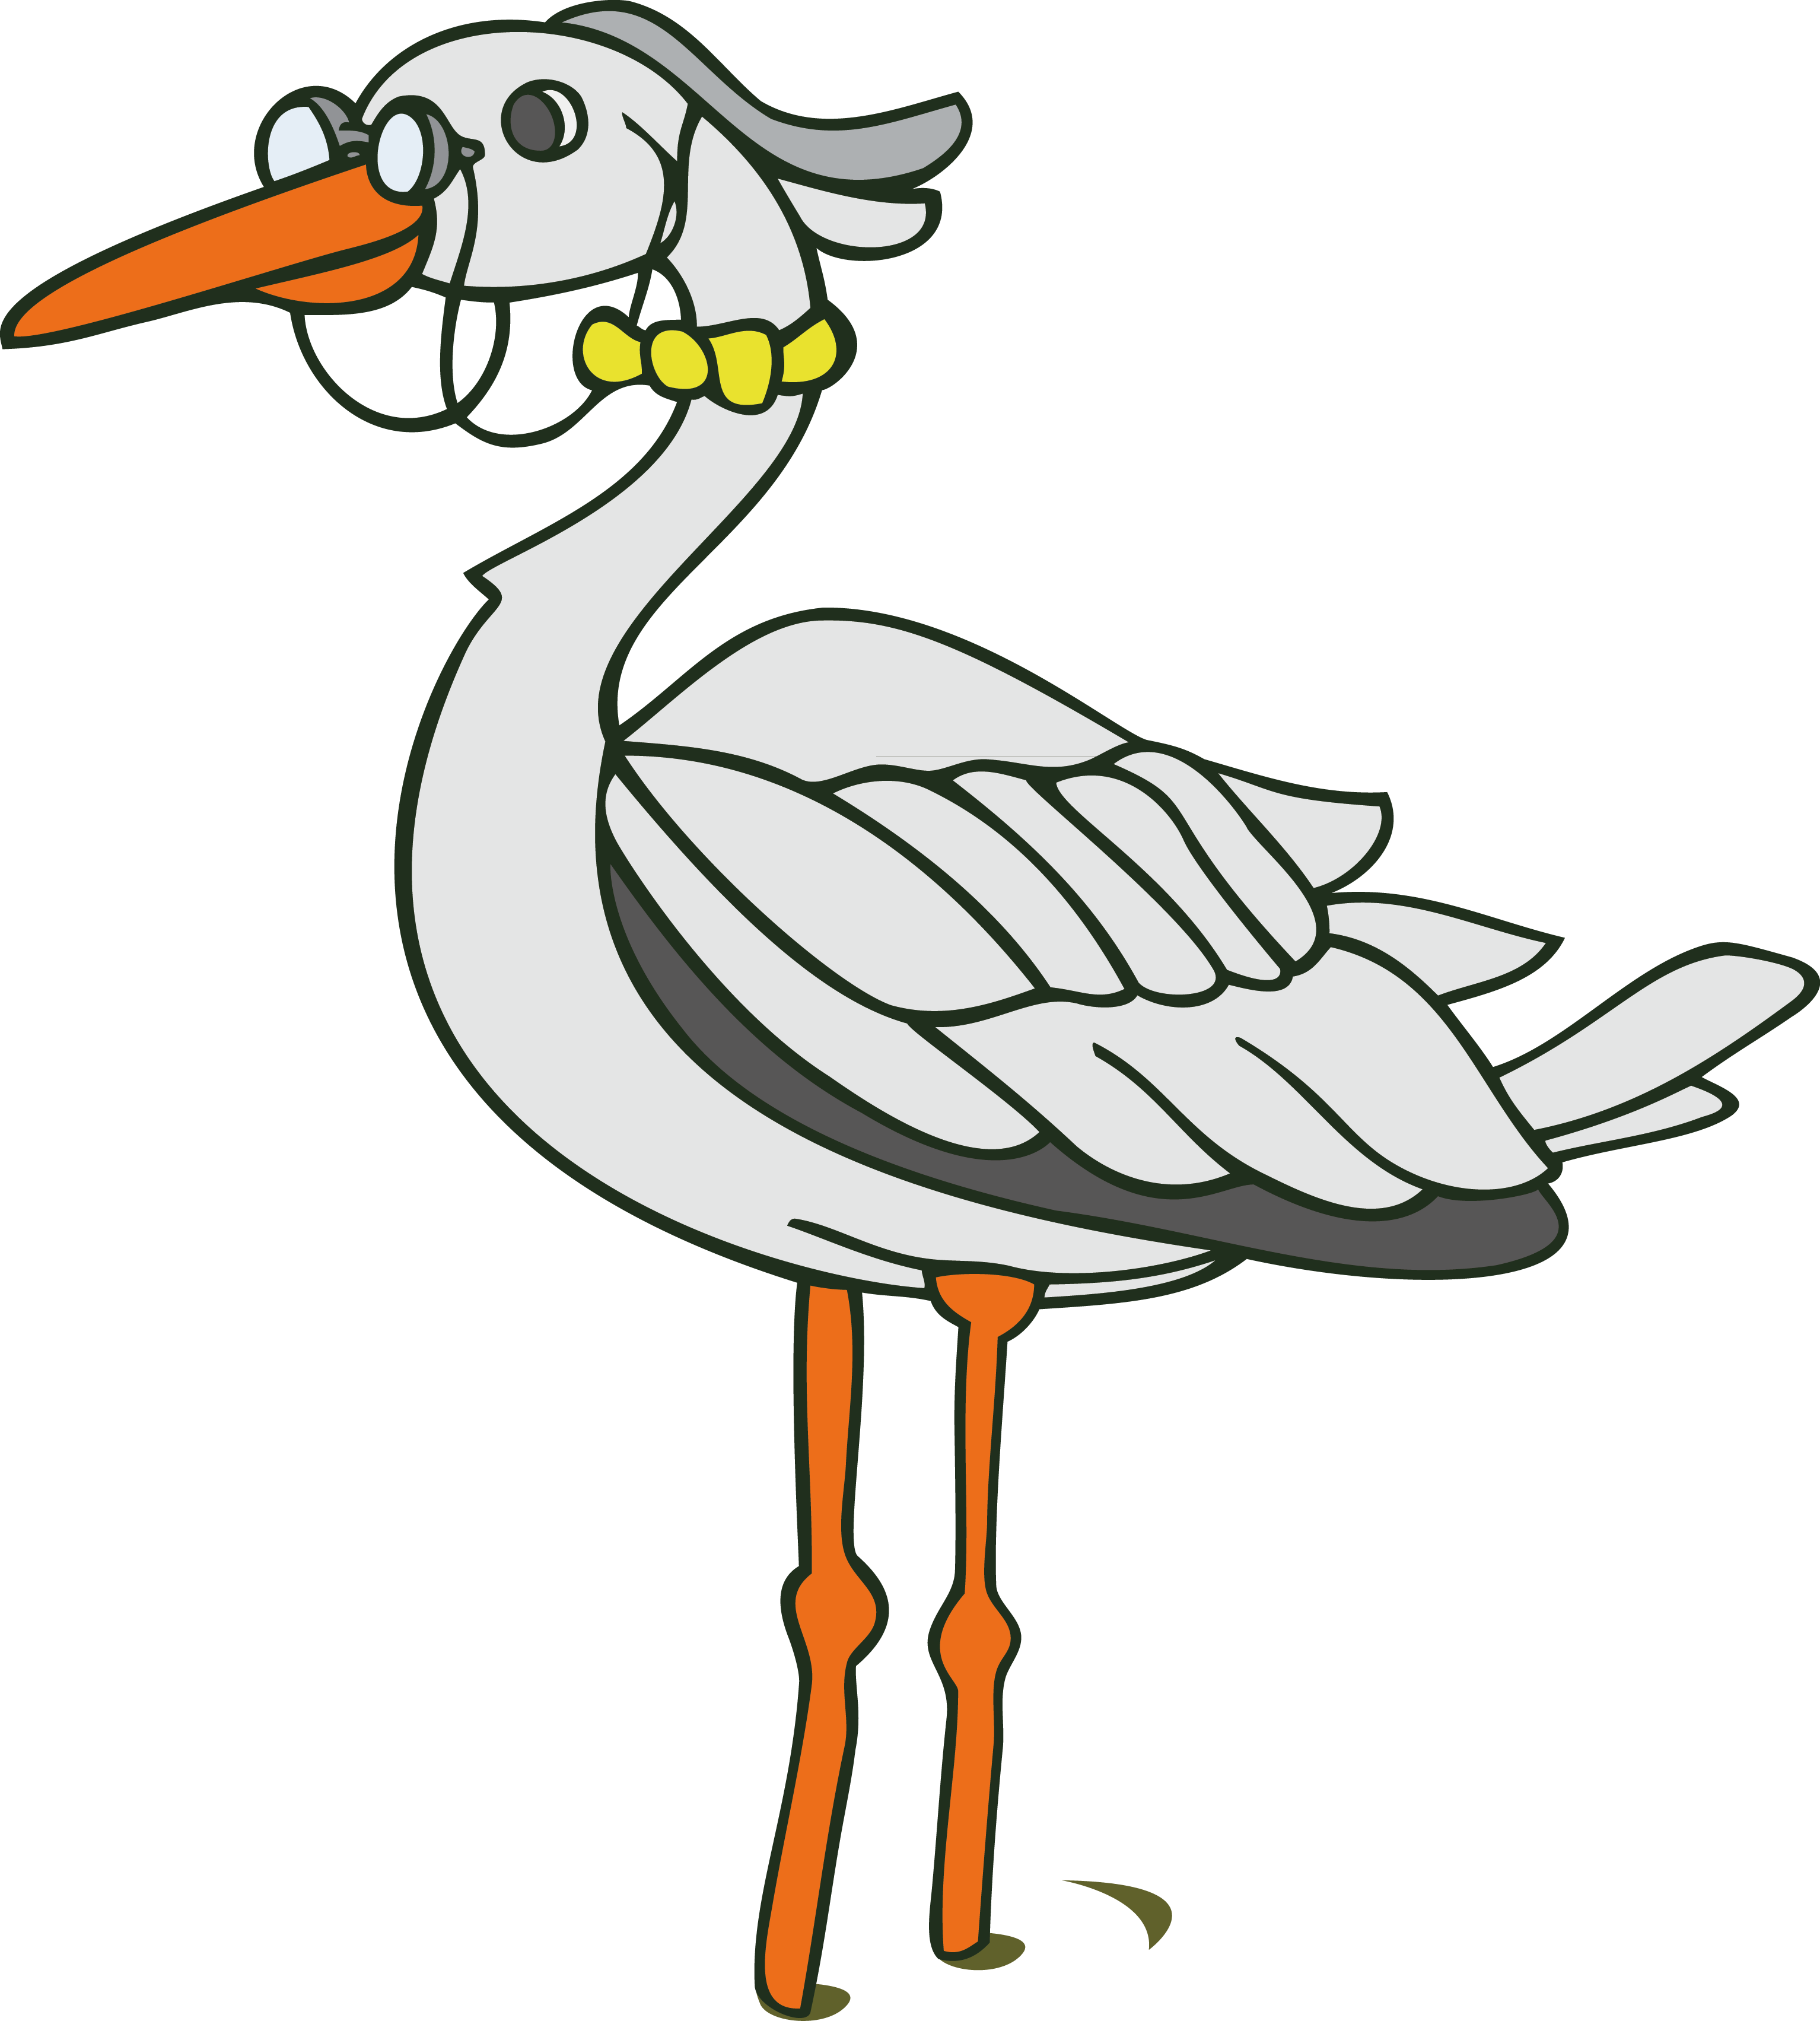
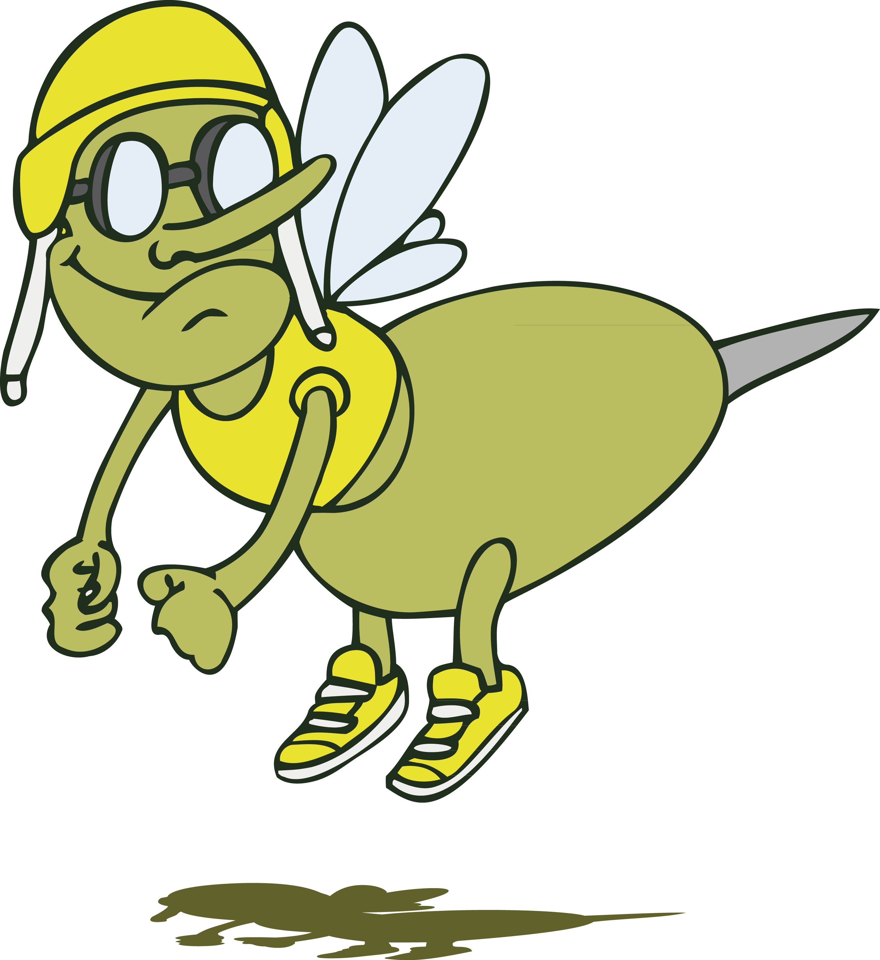

A frog is going through a swamp. There are two kinds of dangers lurking in the swamp – a flamingo, which represents a smaller threat, and a crocodile, an even bigger threat. Then there are the bugs. Bugs give the frog strength because frogs eat bugs. On a lucky day, the frog will make it through without being eaten.
How to Play
These rules are not made by God. Feel free to adapt.
- Players are represented by the frogs, going through a swamp.
- Players should avoid a crocodile space. If a player rolls the dice and lands on a crocodile space, the player has to START AGAIN – Aaaarrrgghhhh!
- There are 3 crocodiles hiding in the game – Watch out!
- If a player lands on a flamingo space, he/she will be asked to go back 2 spaces – Oh no!
- If a player lands on a bug space, he/she will advance 2 spaces – Yeah!
- Roll the dice each time to play. When a player lands on a ‘normal’ space, he/she takes a card from the deck. The player will flip the card and read the word on the card.
- If the player cannot solve the problem he/she can ask for a clue from the teacher/parent. The teacher/parent is there to provide support.
- If the player can’t read the word, sound or sentence after the clue, he/she will not advance (lose a turn), but can choose another card next time.
- Every time a card is used, it is placed face down to start a separate deck.
- If all unused cards are exhausted, shuffle the exhausted deck and continue the game.
- The first player to get to finish wins.

More Ideas for Using the Game
Important Tips
- When you play the game the first time, take time to slowly show the students how to play the game. The best way is to do a trial play. Once they decode the rules and fun factor, you are good next time. You may ruin the game forever if you do not get it right the first time.
- For older students, turn up the fun by insisting that players get the exact number towards finish. For example, if a player is on space 31, rolls the dice and gets 6, then he/she counts 3 forward and 3 backwards. To win, he/she needs to roll and get 3 to win.
- Better to play 2 or more rounds each time to increase the chance of everyone winning at least once. Some kids hate to lose and that is how you work around this problem.
Why this Game Works
- It is fun. Most kids learn when they are not really thinking about the learning. The fun makes learning an enjoyable and unconscious experience, not just another boring teaching session.
- It is effective. When a game combines fun and effectiveness as a teaching tool, you have the right recipe for success. Many educational games do a poor job at combining the fun with the learning. Do not forget that at the end of the day, your goal is to get the knowledge into the students’ heads.
- The game is simple. It is not hard for kids to understand the rules. Learning games lose the fun factor when they are complicated to understand and follow. You do not want to spend time teaching children how to play, instead of getting down to business almost right away.
- It is versatile. You can use this game for just about any kind of teaching. It fits all scenarios. All you need to do is change the knowledge factor. It can be used for teaching math and other subjects. You just need to make new sets of cards.

Author: Futonge N. Kisito is the rightful author of this particular crocodile board game. He developed the game while teaching English to children in China. This game was first published on one of his many sites www.eslgamesworld.com where it became very famous. He has just redesigned and improved the game for www.mathfox.com . The fun, simple, versatile and effective nature of the game is its biggest appeal. If you have any questions, send us feedback here: http://www.mathfox.com/contact/

