Homes Under The Hammer – Maths (Answers)
If you've never seen this daytime television gem, then what happens is that people buy a property in an auction, do it up, then sell or rent it.

Lucy and Martin interview them before and after the renovation and estate agents value the property before and after. There are three houses per episode.
The aim is to make a profit!

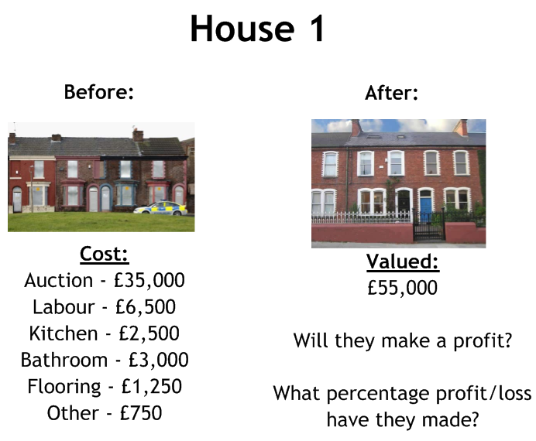
Profit of £6000 or 12.2%

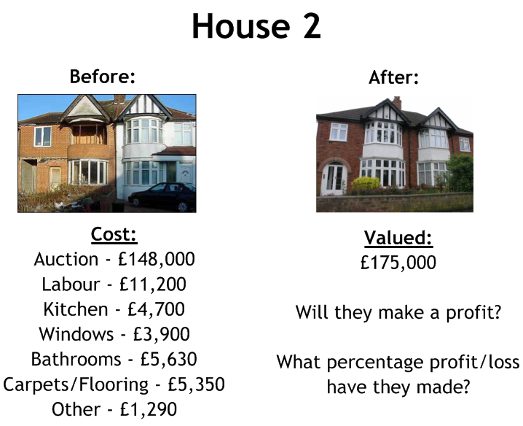
Loss of £5070 or 2.8%

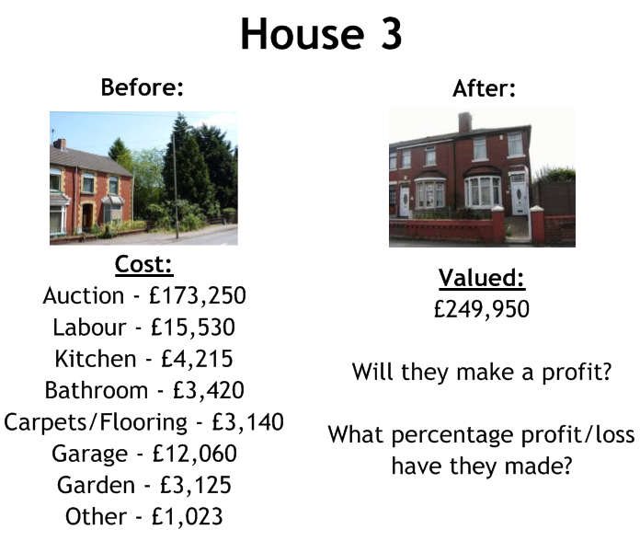
Profit of £34,187 or 15.8%

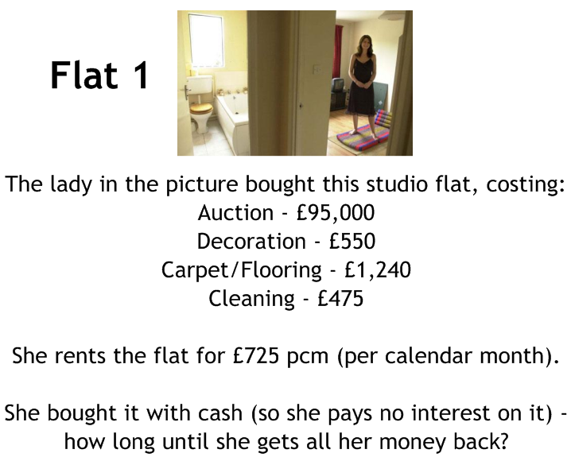
It takes 134 months or 11 years, 2 months

