Name: _____________________________________________ Date:_________________________________________

1 | How I solved it. | 5 | How I solved it
For the following pairs of numbers, which underlined digit is worth more? Circle the number.  1, 632,794 or 783,112 |  | Fraction. Decimal. Percentage.  ½  Convert from fraction to decimal and percentage.
2 | How I solved it. | 6 | How I solved it.
Can you simplify these problems to make them easier to solve?  e.g. 99 – 44 = 100 – 44 = 56 - 1 = 55  1, 81 – 39 = |  | Tom says to Lucy, “Last month I saved 0.25 of my pocket money and this month I saved 2/5 of my pocket money, so all together I have saved 60% of my pocket money”. Is what Tom says true or false? Explain your decision?
3 | How I solved it. | 7 | How I solved it.
Can you simplify these problems to make them easier to solve?  e.g. 53 – 82 + 47 = 53 + 47 – 82 = 100 – 82 = 18  1, 20 X 7 X 5 = |  | Liam hires a bike, he has to return it by 3pm, the time is 2:25 pm. How many minutes has he got left?
4 | How I solved it. | 8 | How I solved it.
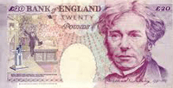  You have £20.00 to pay for three items, they cost cost £1.24, 7.92 and £2.55. How much change should you get back? |  | 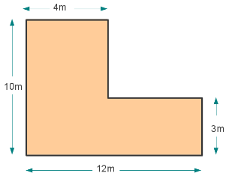  I want to buy carpet for my front room, can you calculate the area of the  floor so that I know how much carpet  to buy.

