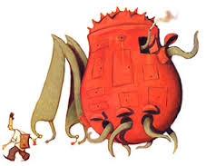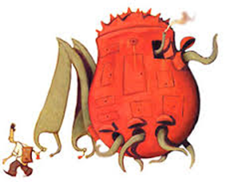

**Shaun finds these bottle tops to add to his collection, but isn’t sure what each one means.**

**Can you work out what the letters y and b mean?**

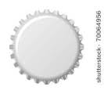          

Y= 309 + 120

98 ÷ 6 = b

67 ÷ 4 = y

97 ÷5 = b

34 ÷ 3 = y

B = 142 x 6

B= 34 x 2

B = 73 x 5

B = 42 x 3

Y = 12+17

Y = 123 +72

Y = 17+8