**One of the scientific tests that Pete gives the Lost Thing to work out what it is, is the ‘Numberline Test’.**

**He puts the Lost Thing at one end and sees how many numbers it covers with each step.**

**It covers 5 each time – The first step is 0, then it puts its foot on 5, then its next foot goes on 10 and so on.**

 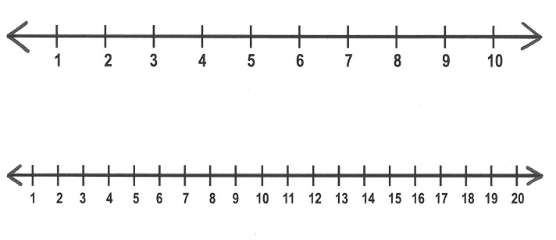

**Investigate these questions like Pete would have done.**

1. **What is the pattern in the ones place? What would the next number in the pattern be and why?**
2. **What is the pattern of digits in the tens place? What would the next number be and why?**
3. **What is the ‘even or odd’ pattern?**
4. **What is the pattern of the sum of each pair of number in the pattern? Eg, 0+5, 10+15**
5. **What happens if the Lost Thing took a jump and started stepping on the number 2? Remember he can only walk in steps of 5!**

**Try this again but for this Lost Thing – it can only walk in steps of 4**

