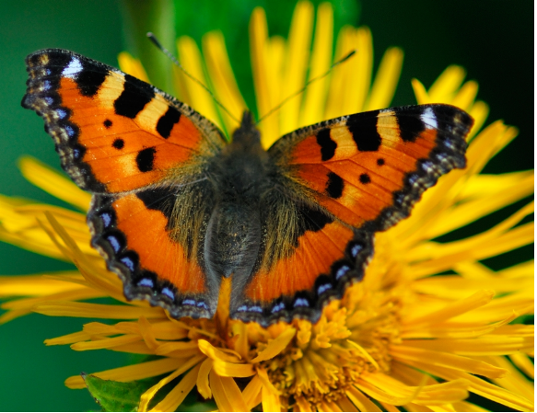
butterfly
legs 6
size 10
popularity 10
camouflage 0

bumblebee
legs 6
size 6
popularity 6
camouflage 1

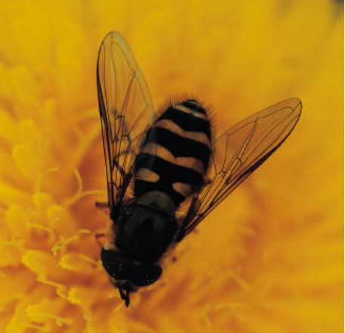

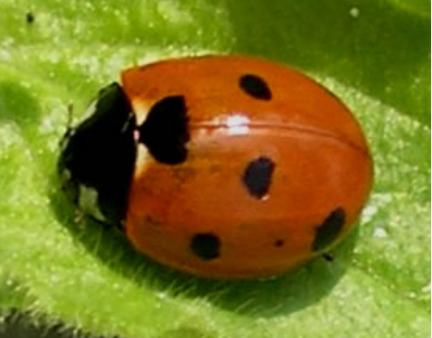
ladybird
legs 6
size 1
popularity 10
camouflage 0

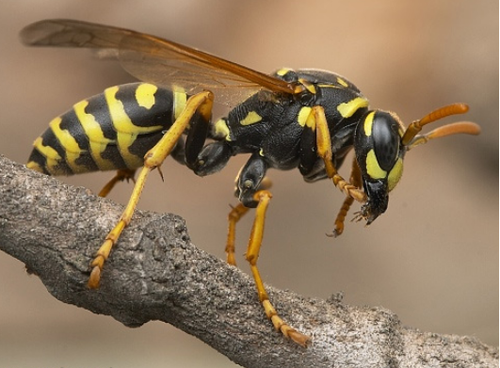

wasp
legs 6
size 5
popularity 0
camouflage 1

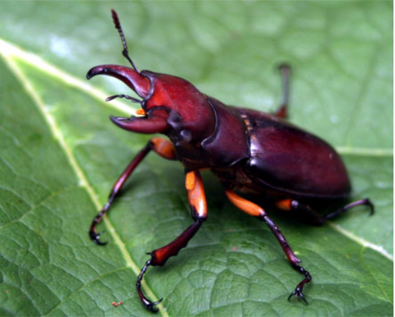

stag beetle
legs 6
size 4
popularity 6
camouflage 6

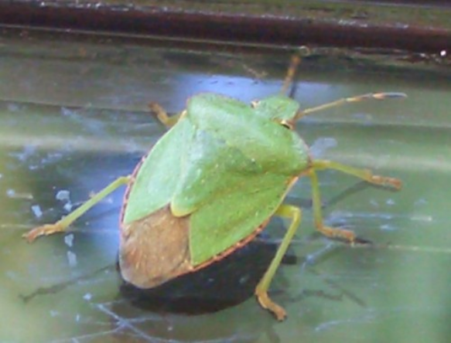
shield bug
legs 6
size 5
popularity 5
camouflage 10

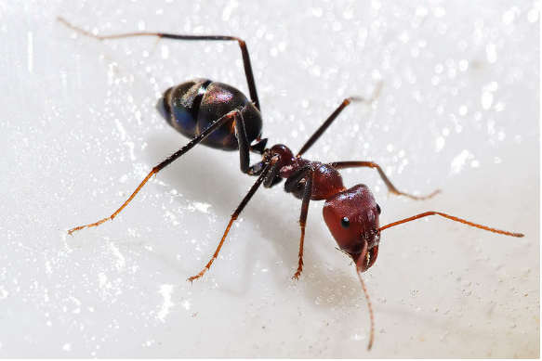
ant
legs 6
size 0
popularity 3
camouflage 7

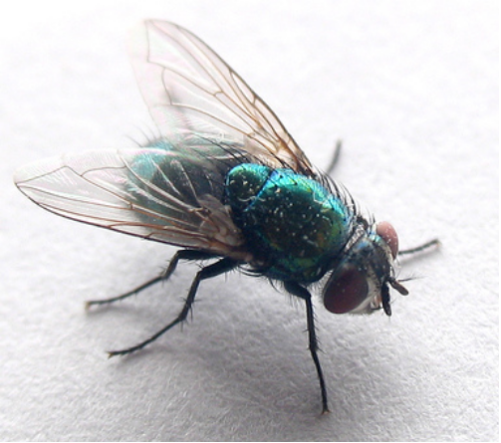
fly
legs 6
size 1
popularity 0
camouflage 2

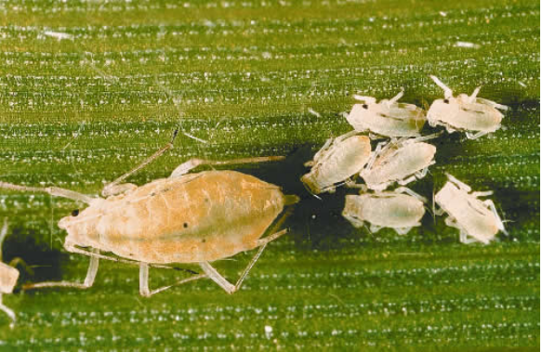

aphid
legs 6
size 0
popularity 2
camouflage 9

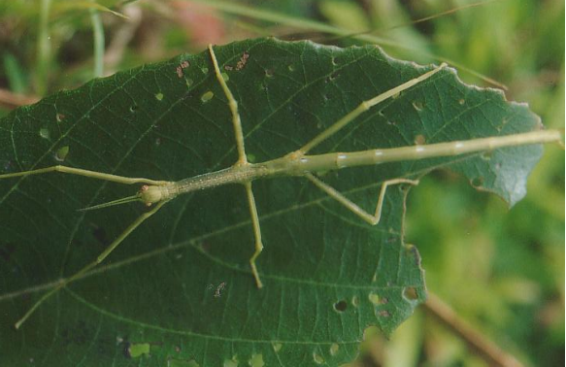

stick insect
legs 6
size 7
popularity 8
camouflage 10

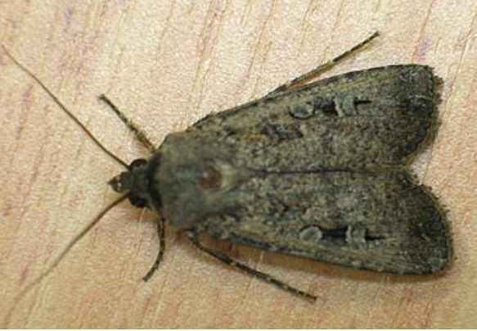

moth
legs 6
size 9
popularity 8
camouflage 9

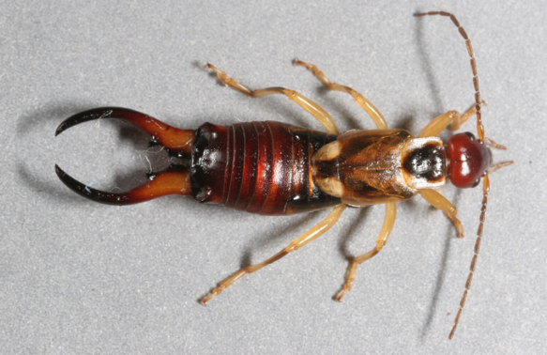

earwig
legs 6
size 4
popularity 2
camouflage 5

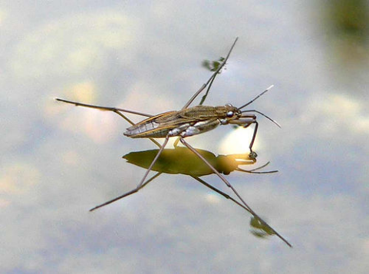

pond skater
legs 6
size 1
popularity 7
camouflage 8

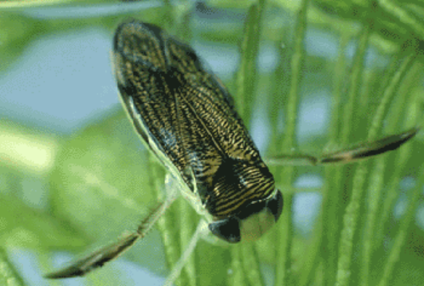

water boatman
legs 6
size 2
popularity 7
camouflage 8

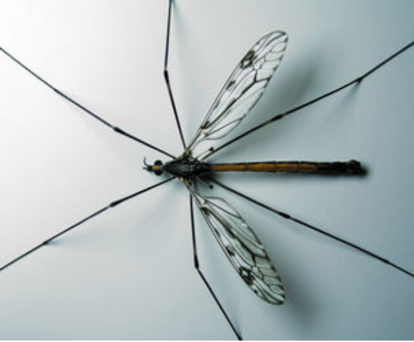
crane fly
legs 6
size 8
popularity 5
camouflage 4

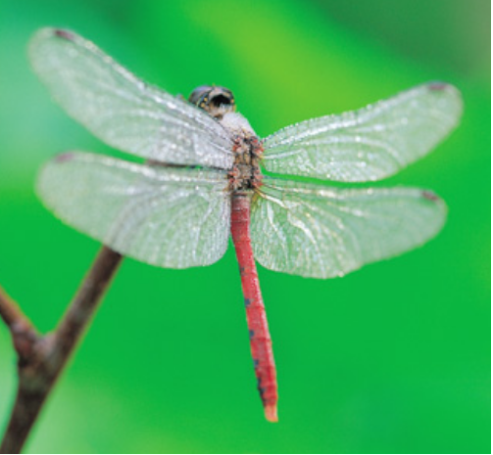
dragonfly
legs 6
size 8
popularity 9
camouflage 2

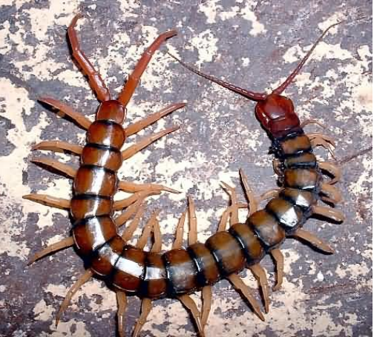
centipede
legs up to 177
size 3
popularity 2
camouflage 4

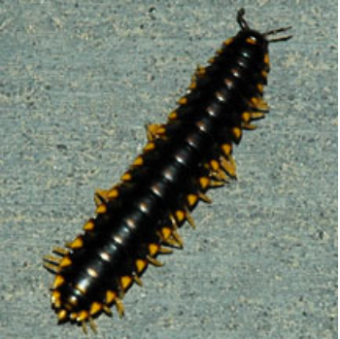

millipede
legs up to 200
size 3
popularity 2
camouflage 5

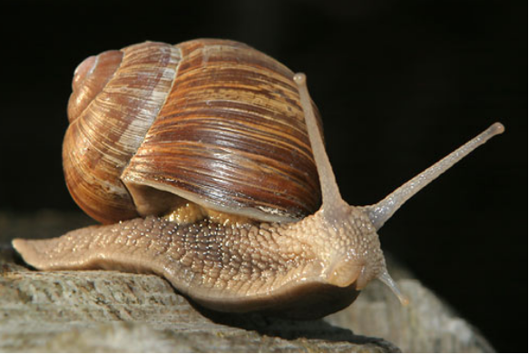
snail
legs 0
size 7
popularity 3
camouflage 5

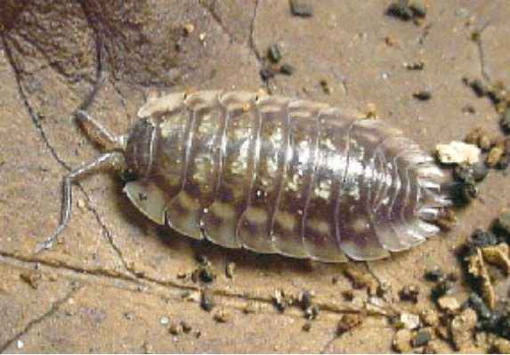

woodlouse
legs 14
size 2
popularity 4
camouflage 6

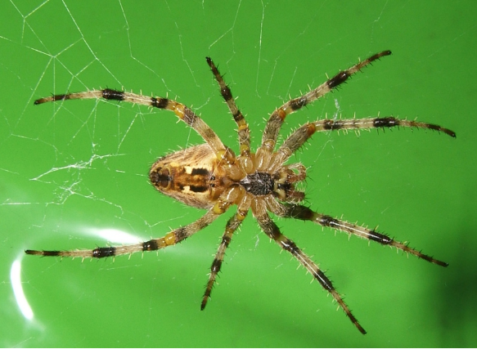
spider
legs 8
size 4
popularity 3
camouflage 6

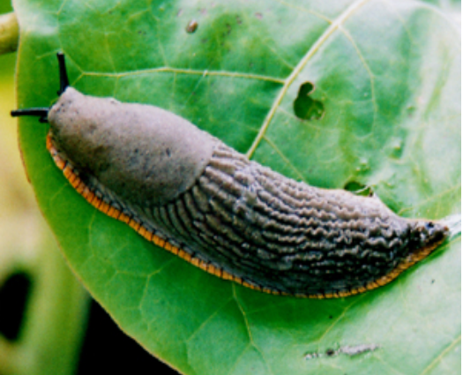
slug
legs 0
size 10
popularity 0
camouflage 3

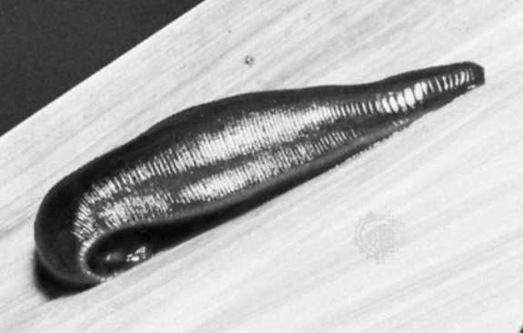

leech
legs 0
size 6
popularity 1
camouflage 3

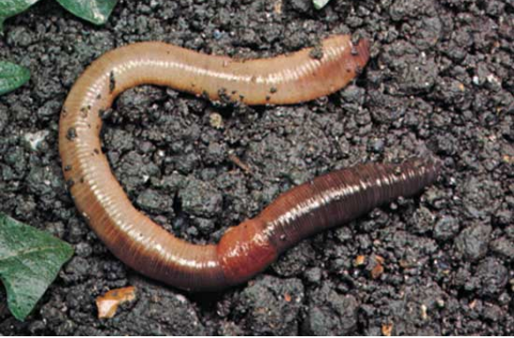

earthworm
legs 0
size 9
popularity 9
camouflage 2

