The Sun

Mercury

Earth

Venus

**Diameter 12,756 km**

**Temperature 22°C**

**Speed 66,641 mph**

**Mass 5.97**

**Year of Discovery N/A**

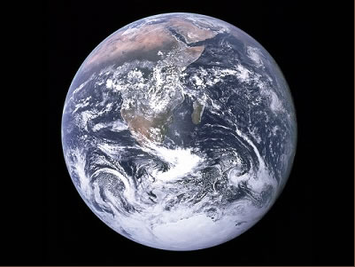

Our home, some 4.5 billion years old. Life appeared on the surface just 1 billion years after creation, with human beings appearing just 200,000 years ago.

**Diameter 12,104 km**

**Temperature 482°C**

**Speed 78,364 mph**

**Mass 4.86**

**Year of Discovery N/A**

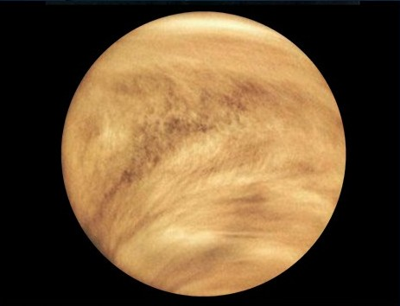

Venus is our neighbouring planet. It is impossible to state when Venus was discovered as it is visible with the naked eye.

**Diameter 1,391,000 km**

**Temperature 6000°C**

**Speed 136 mph**

**Mass 1,989,000**

**Year of Discovery N/A**

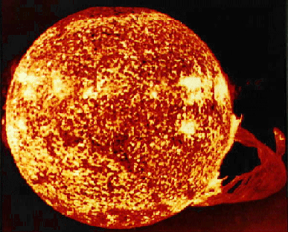

The Sun is the star at the centre of our Solar System. Its mass is approximately 330,000 times heavier than our home planet and is 109 times wider. The Sun is the largest object in our Solar System.

**Diameter 4878 km**

**Temperature 427°C**

**Speed 107,132 mph**

**Mass 0.33**

**Year of Discovery 1885**

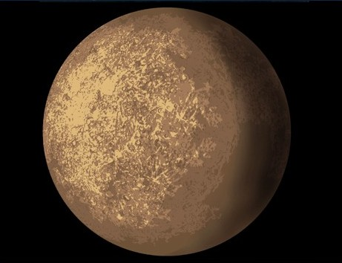

Mercury is the closest planet to the Sun, orbiting our star at an average distance of 57.9 million kilometres, taking 88 days to complete a trip around the sun. Mercury is also the smallest planet in our Solar System.

**Mercury**

Mercury is the closest planet to the sun, orbiting our star at an average distance of 57.9 million kilometres, taking 88 days to complete a trip around the sun. Mercury is also the smallest planet in our solar system.

**Diameter 51,118 km**

**Temperature -214°C**

**Speed 15,234 mph**

**Mass 86.81**

**Year of Discovery 1781**

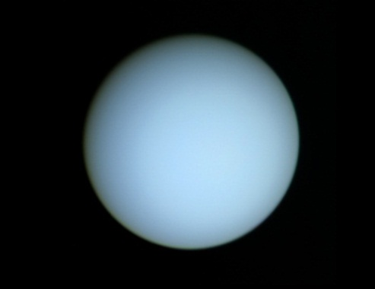

Uranus was the first planet to be discovered by a telescope, and is also visible to the naked eye. Uranus is sometimes referred to as an ice giant.

**Diameter 120,536 km**

**Temperature -180°C**

**Speed 21,565 mph**

**Mass 568**

**Year of Discovery 700 BC**

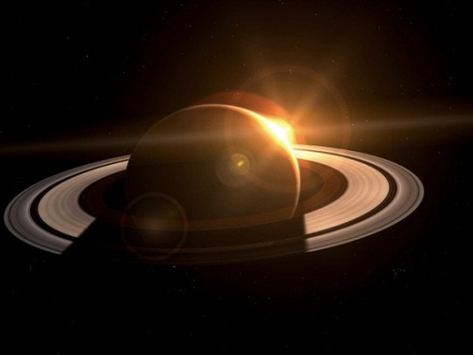

Saturn is the sixth planet from the Sun and the second largest planet in our Solar System. Probably best known for the rings that surround it, experts believe these rings formed from a destroyed moon millions of years ago.

**Diameter 142,800 km**

**Temperature -150°C**

**Speed 29,216 mph**

**Mass 1898**

**Year of Discovery 1610**

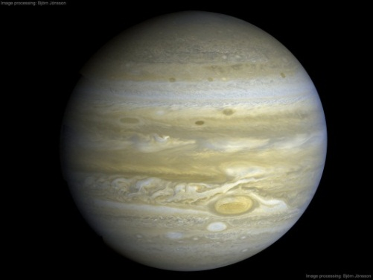

Jupiter is the largest planet in our Solar System. Described as a ‘gas giant’ it orbits our Sun at a distance of 778,000,000 kilometres. A distinct feature of Jupiter is the ‘great red spot’ which is a storm that has lasted for more than 400 years.

**Diameter 6794 km**

**Temperature -15°C**

**Speed 53,980 mph**

**Mass 0.64**

**Year of Discovery 1580**

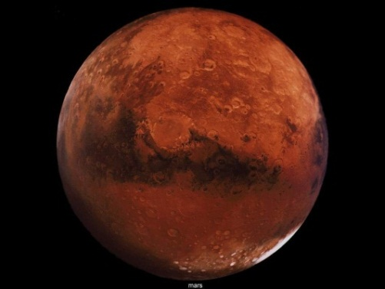

The fourth planet from the Sun. The surface of Mars consists of iron oxide which gives the planet a red appearance. Mars is approximately half the width of the Earth and is also a neighbouring planet to us.

Uranus

Saturn

Jupiter

Mars

Ganymede

Titan

The Moon

Neptune

**Diameter 5150 km**

**Temperature -174°C**

**Speed 12,482 mph**

**Mass 0.13**

**Year of Discovery 1655**

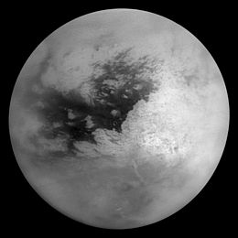

Titan is a moon of Saturn, the largest that orbits the planet. Titan is twice the size of our moon and it is even larger than Mercury.

**Diameter 5262 km**

**Temperature -297 to -171°C**

**Speed 24,337 mph**

**Mass 0.14**

**Year of Discovery 1610**

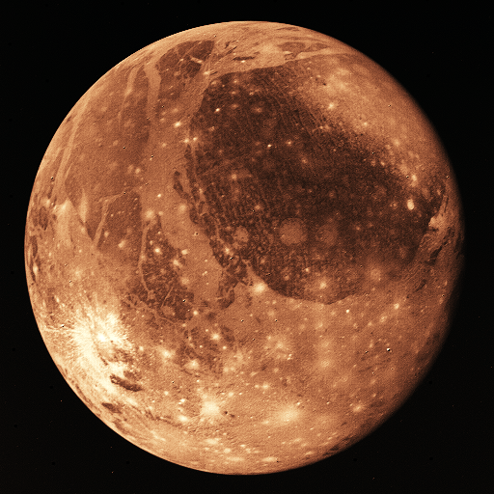

Ganymede is a moon of the planet Jupiter, made of mainly rock and ice. Ganymede orbits Jupiter every 7 days and 3 hours.

**Diameter 3476 km**

**Temperature -233 to 123°C**

**Speed 2,300 mph**

**Mass 0.07**

**Year of Discovery N/A**

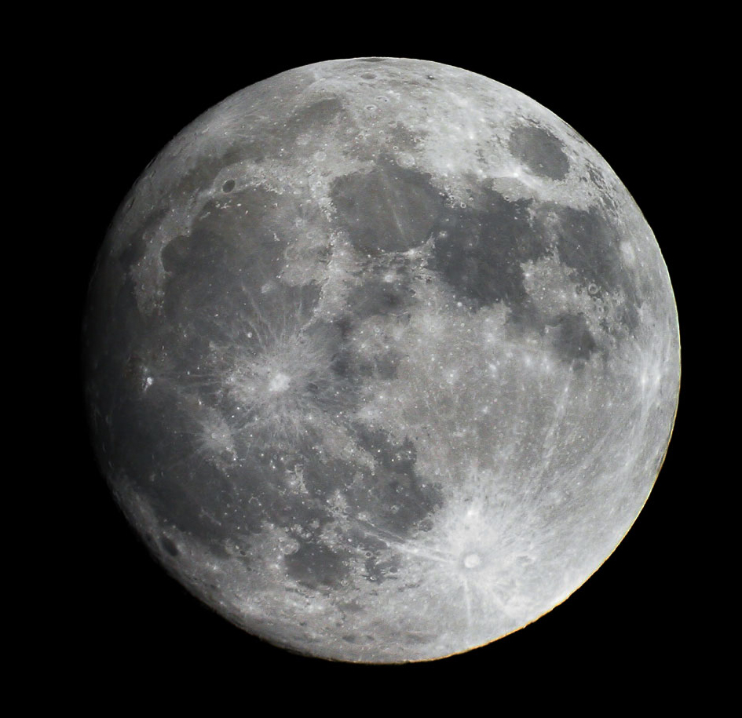

The moon is roughly one quarter the size of the Earth. It orbits our Earth every 28 days, and is the cause of tides you see on the beach!

**Diameter 50,538 km**

**Temperature -220°C**

**Speed 12,147 mph**

**Mass 102.43**

**Year of Discovery 1846**

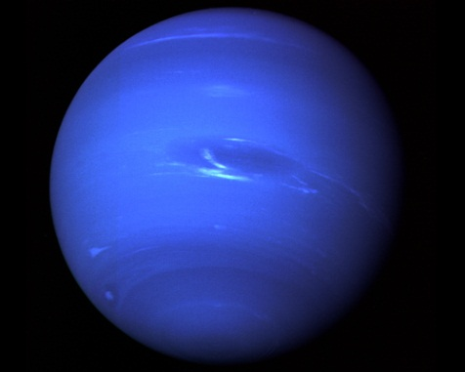

Neptune is the eighth planet from the Sun and is 17 times the mass of the Earth. Storms on the planet have wind speeds of up to 2,100 kilometres per hour.

**Diameter 2300 km**

**Temperature -230°C**

**Speed 7,672 mph**

**Mass 0.01**

**Year of Discovery 2005**

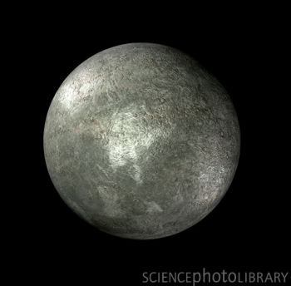

Eris was only recently discovered. It is classified as a ‘dwarf planet’ and orbits our Sun three times as far away as Pluto.

**Diameter 2324 km**

**Temperature -230°C**

**Speed 12,482 mph**

**Mass 0.13**

**Year of Discovery 1930**

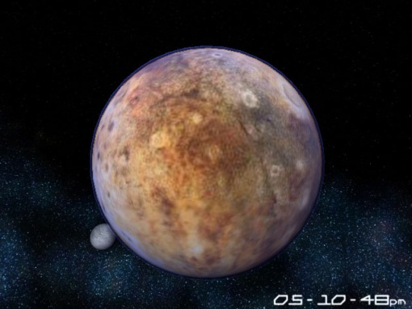

Pluto was recently declassified as a planet in 2006, as scientists observed many objects the size of Pluto orbiting our Sun at the same distance. It takes Pluto 248 years to orbit the Sun.

**Diameter 3138 km**

**Temperature -160°C**

**Speed 30,735 mph**

**Mass 0.04**

**Year of Discovery 1610**

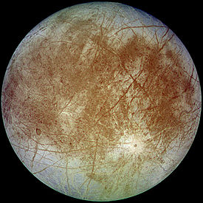

Europa is the closest moon to orbit the planet Jupiter. Slightly smaller than our moon, many scientists believe there is a possibility that life may exist here.

**Diameter 3642 km**

**Temperature -143°C**

**Speed 38,774 mph**

**Mass 0.08**

**Year of Discovery 1610**

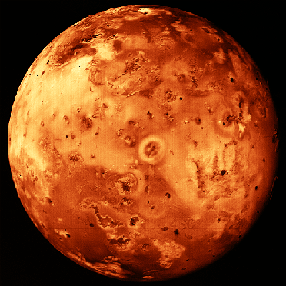

Another moon of Jupiter, Io (pronounced *eye-oh*) is the second largest moon to orbit the planet, and has over 400 active volcanoes on its surface.

Eris

Io

Pluto

Europa

Ariel

Callisto

Deimos

Phobos

**Diameter 1056 km**

**Temperature -187°C**

**Speed 12,347 mph**

**Mass 0.001**

**Year of Discovery 1851**

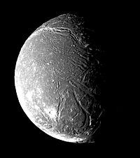

Ariel is one of the 27 moons that orbits Uranus. Composed of rock and ice, this moon orbits Uranus every 2.5 days. Not much is known about this moon, would you care to visit and find out?

**Diameter 4820 km**

**Temperature -172°C**

**Speed 18,342 mph**

**Mass 0.1**

**Year of Discovery 1610**

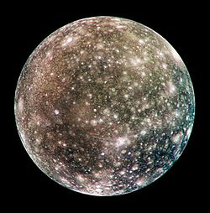

Callisto is the 3rd largest moon in our Solar System and is almost exactly the same width as Mercury. The moon is made of rock and ice, and scientists believe that there may be life in oceans that lay beneath the ice layer on the surface.

**Diameter 6.2 km**

**Temperature -4°C**

**Speed 2,908 mph**

**Mass 0.00000001**

**Year of Discovery 1877**

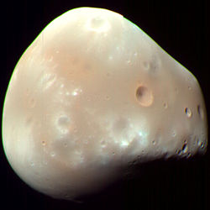

The other of the two moons that orbits Mars. Deimos is only 6.2 kilometres wide, making it one of the smallest moons in our Solar System.

**Diameter 11.1 km**

**Temperature -4°C**

**Speed 4,697 mph**

**Mass 0.00000001**

**Year of Discovery 1877**

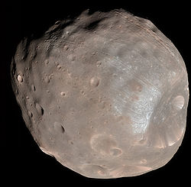

Phobos is one of two moons that orbits the planet Mars. Phobos orbits Mars so close that one day it will impact possibly causing a planetary ring similar to Saturn’s.

Mimas

1 Ceres

***Solar System***

***Top Trumps***

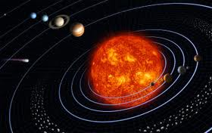

**Diameter 396 km**

**Temperature -209°C**

**Speed 32,032 mph**

**Mass 0.00003**

**Year of Discovery 1789**

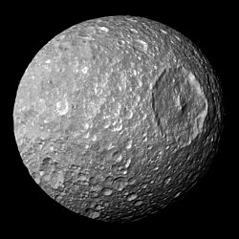

Mimas is a moon of Saturn. It is the 20th largest moon in the Solar System. The most distinctive feature of this moon is the colossal 130 kilometre wide impact crater, what could have caused this?

**Diameter 950 km**

**Temperature -38°C**

**Speed 38,027 mph**

**Mass 0.0009**

**Year of Discovery 1801**

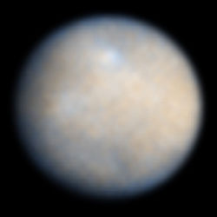

1 Ceres is the smallest dwarf planet in the Solar System. It orbits our Sun within the asteroid belt that is located between Mars and Jupiter and is made of ice and clay.

**RULES**

1. THE PLAYER WITH THE HIGHEST DIAMETER WINS.
2. THE PLAYER WITH THE TEMPERATURE CLOSEST TO EARTHS TEMPERATURE WINS.
3. THE PLAYER WITH THE HIGHEST PLANET/MOON SPEED WINS.
4. THE PLAYER WITH THEHIGHEST MASS WINS.
5. THE PLAYER WITH THE EARLIEST YEAR OF DISCOVERY WINS.
6. IF A PLAYER HAS N/A FOR AN ANSWER, THE CARD IS PLACED IN THE MIDDLE AND THE WINNER OF THE NEXT TURN RECEIVES THE CARD(S) FROM THE MIDDLE. THE SAME RULE ALSO APPLIES TO CARDS WITH THE SAME VALUE AS AN ANSWER.