Superman Co-ordinate Pythagoras - Answers
Calculate the exact distances Superman has to fly for each leg of his journey below to engage the villains who are making trouble.
He flies in a straight line from point to point in the order below and each square is a kilometre.
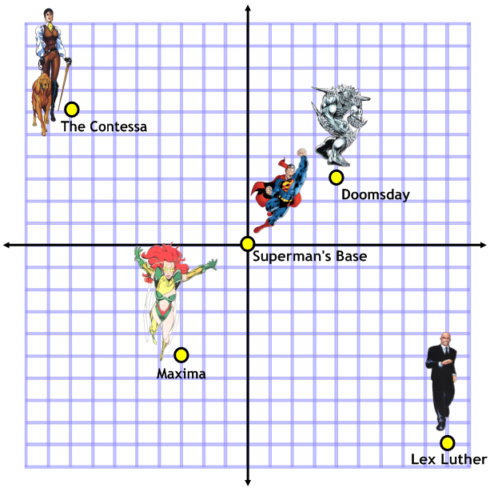
Base to Doomsday:
5 km
…………………………………………………………………………………………………………………………
Doomsday to The Contessa:
12.4 km
…………………………………………………………………………………………………………………………
The Contessa to Maxima:
12.1 km
…………………………………………………………………………………………………………………………
Maxima to Lex Luther:
…………………………………………………………………………………………………………………………
12.6 km

Iron Man Co-ordinate Pythagoras
Calculate the exact distances Iron Man has to fly for each leg of his journey below to engage the villains who are making trouble.
He flies in a straight line from point to point in the order below and each square is a kilometre.
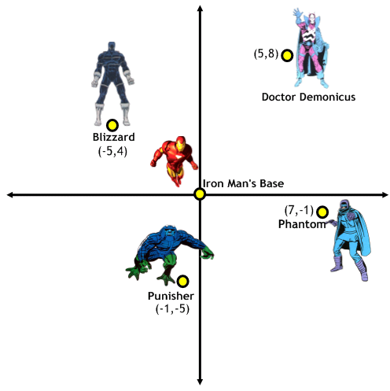
Base to Phantom:
7.1 km
…………………………………………………………………………………………………………………………
Phantom to Punisher:
8.9 km
…………………………………………………………………………………………………………………………
Punisher to Blizzard:
9.8 km
…………………………………………………………………………………………………………………………
Blizzard to Doctor Demonicus:
10.8 km
…………………………………………………………………………………………………………………………

