www.thinkingclassroom.co.uk
ThinkSheet #34 : Mathematics : Data
Thinking Classroom ideas for thinking creatively about data

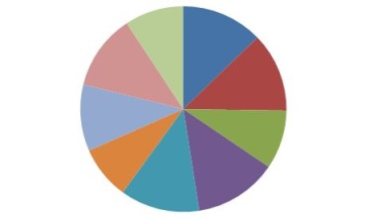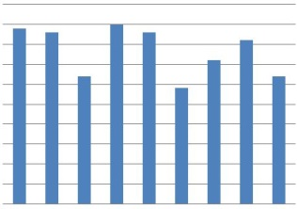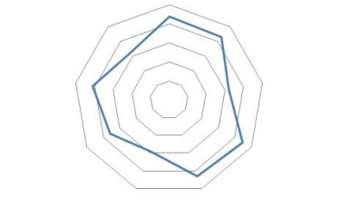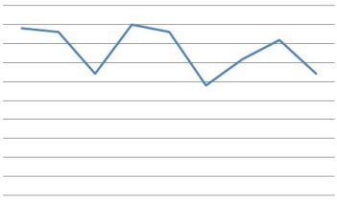

- Which graph/chart gets your attention the most and why?
- Rank them in order of how common they are – how often they are used/do they appear in everyday life?
- Think of humorous information/a funny situation that one or more of these might be showing
- How could each one be used to describe some feature of a fairy tale or horror movie?
- If each one is related in some way to money, what might be shown?

Home Tasks
1. Find a graph or chart (book/magazine/internet) and remove its title and axes details. Present in class and take guesses as to what the missing information might be.
2. These 50 numbers are related to Hollywood and to action movies. What are they? Have your teacher Tweet @MikeTweetham for further clues.

26,29,40,40,52,32,45,44,58,30,31
60,23,39,48,41,40,36,36,33,42,35
50,43,47,42,32,38,29,28,44,43,32
45,43,29,36,41,32,39,40,44,21,31
36,49,29,45,35,45

Fact Climb
Respond to the facts at the bottom of the ladder by starting at a rung that’s not too hard and not too easy. Then climb up. See Issue 36 for more information on Fact Climbs.

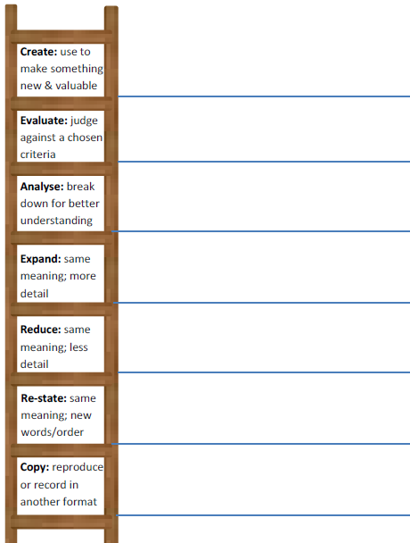
Info graphics
How could the image of a meal across three plates be used as an infographic to show information in no way related to food/nutrition/health?
For example spending/budgets; use of available time; changes over time

Facts*: in 1946, the number of cinema admissions in the UK was 1635 million. By 1984 it had dropped to 54 million yet in 2012 it had increased to 172 million.
*http://www.launchingfilms.com/research-databank/uk-cinema-admissions

