The Walking Dead – Season 4 – Area and Perimeter - Answers
Deputy Crimes and his fellow survivors have found a group of mathematically shaped islands which are unaffected by the zombie apocalypse as they were uninhabited. Can you find the area of each island so Deputy Crimes can start populating each one?
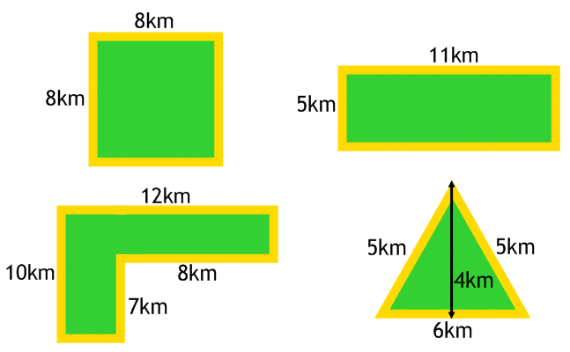
12km²
4 people
16km
64km²
21 people
44km
64km²
21 people
32km
55km²
18 people
32km
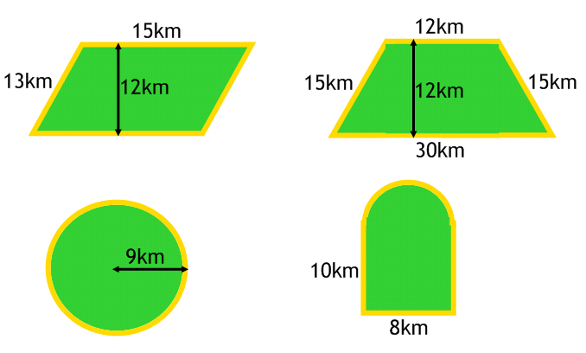
105.1km²
35 people
40.6km
254.5km²
84 people
56.5km
252km²
84 people
72km
180km²
60 people
56km
Each person requires 3km² in order to grow enough food to survive. How many people can survive on each island?
There are rumours of a zombie invasion from the mainland so Deputy Crimes has decided to put a fence around the perimeter of the island. How much fencing is required for each island?

Deputy Crimes has decided that all the survivors are better off in one place. He has found the deserted island below. He wants to house 120 survivors on the island and has 150km of fencing.
Is this possible if each person requires 3km² of land and the fencing must go around the whole island? You must show your workings!
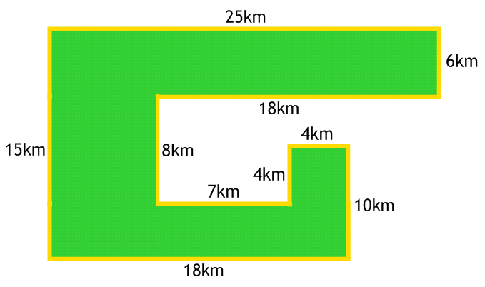
Perimeter: 115km – Deputy Crimes has enough fencing
Area: 330km² – not enough room for 120 people (110 people only)

