Red Bird

Red Bird is the main character in the Angry Birds. He is also the leader of the Flock. Luckily Red is able to cause great damage to the weaker structures. Gently, Red cares for the eggs. He sometimes dresses them up by putting a cap on them to keep them cool, making him the one with the best caring skills. His best friend is Chuck. He regularly reassures and encourages his friends. Red is also known for being a strong and responsible leader and for never giving up on protecting the eggs from the Pigs. Red is a large bird whose fur is softer than clouds. He has a small beak on the front of his puffy face and huge angry eyebrows.

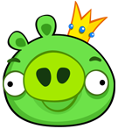

Yellow Bird

Chuck, the Yellow Bird is a character in the Angry Birds. Unlike the other birds, he is cone shaped, with a mop of black head feathers and red eyebrows. Chuck has a very mixed personality, he is enthusiastic but big-headed. He always wants to be the best of the Flock, and is one of the most restless Birds. Chuck is very strong when thrown at wood, making him a good bird to use. However, he can't destroy square blocks very well and can only shatter one square block. Unfortunately, He can't do much damage to glass. When Chuck is first launched from the slingshot, he flies at an angle like most birds. However, when his rush ability is activated, he will shoot straight at the target.

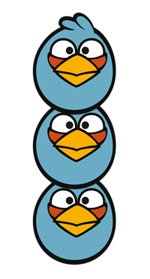

Blue Bird
Jay, Jake, and Jim, otherwise known as the Blue Birds are characters in the Angry Birds. The Blues, unlike the others, get surprised when it comes to egg theft and smuggled birds. They are daring and inquisitive and often get themselves into trouble and cause mischief, causing the Flock to have to intervene. They are the youngest members of The Flock. While the Blues do not cause much damage with most obstacles, they do have a unique strength against glass/ice, able to penetrate it with surprising ease. The Blues are the only birds who have no eyebrows but they have a large yellow beak on the front of their face.

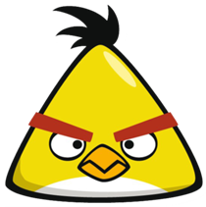

Piggy
The King Pig is the main enemy of the Angry Birds, and serves as the leader of the Bad Piggies. His master plan is using his minions to capture un-hatched eggs from the birds to use as food. It is revealed that his stash is always empty although his subjects believe the stash is always full of eggs. While he does succeed on most occasions, the birds are able to destroy his army and retrieve the eggs. Unfortunately, King Pig never quits and always somehow recovers. King pig is the largest of the pig characters with a stumpy snout on the front of his face. His tiny ears sit on the peak of his round head.
