X-Men Angles
Charles Xavier has asked Wolverine to run an "Angles" class at the "School for Gifted Children". The trouble is that Wolverine's angle knowledge is a bit rusty.
Can you help Wolverine with the following questions he's set and explain the reasons behind the answers?
 | Question | Answer and Reason
1 |  | a = ………………˚ because ……………………………  …………………………………………………………………..  …………………………………………………………………..
2 |  | b = ………………˚ because ……………………………  …………………………………………………………………..  …………………………………………………………………..
3 |  | c = ………………˚ because ……………………………  …………………………………………………………………..  …………………………………………………………………..
4 |  | d = ………………˚ because ……………………………  …………………………………………………………………..  …………………………………………………………………..
5 | 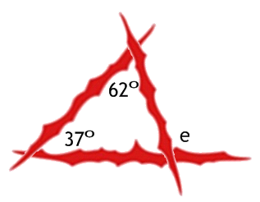 | e = ………………˚ because ……………………………  …………………………………………………………………..  …………………………………………………………………..
6 | 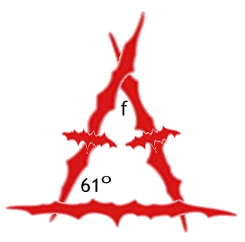 | f = ………………˚ because ……………………………  …………………………………………………………………..  …………………………………………………………………..
7 | 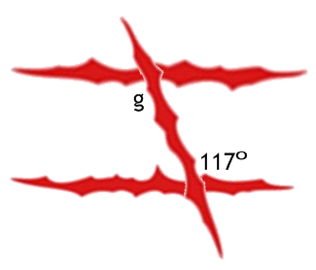 | g = ………………˚ because ……………………………  …………………………………………………………………..  …………………………………………………………………..
8 |  | h = ………………˚ because ……………………………  …………………………………………………………………..  …………………………………………………………………..
9 | 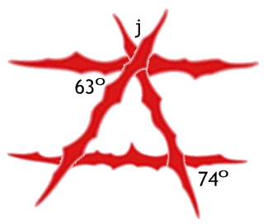 | j = ………………˚ because ……………………………  …………………………………………………………………..  …………………………………………………………………..
10 |  | k = ………………˚ because ……………………………  …………………………………………………………………..  l = ………………˚ because ……………………………  …………………………………………………………………..

