X-Men Angles - Answers
Charles Xavier has asked Wolverine to run an "Angles" class at the "School for Gifted Children". The trouble is that Wolverine's angle knowledge is a bit rusty.
Can you help Wolverine with the following questions he's set and explain the reasons behind the answers?
 | Question | Answer and Reason
1 |  | a = 64˚ because angles on a straight line add to 180˚.
2 |  | b = 78˚ because angles around a point add to 360˚.
3 |  | c = 54˚ because angles in a triangle add to 180˚.
4 |  | d = 104˚ because angles in a quadrilateral add to 360˚.
5 | 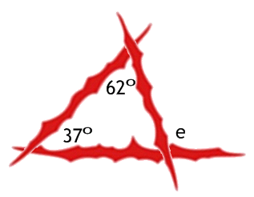 | e = 99˚ because angles in a triangle add to 180˚ and angles on a straight line add to 180˚.
6 | 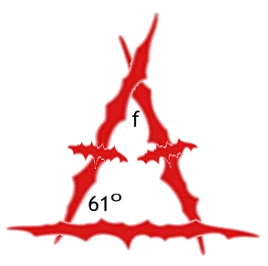 | f = 58˚ because two angles of an isosceles triangle are equal and a triangle adds to 180˚.
7 | 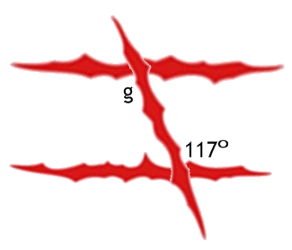 | g = 117˚ because alternate angles are equal.
8 |  | h = 53˚ because corresponding angles are equal.
9 | 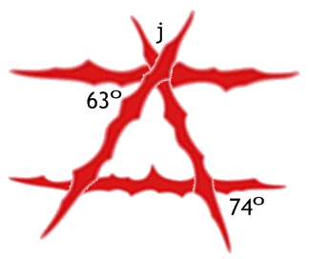 | j = 43˚ because corresponding angles are equal and angles on a straight line add to 180˚.
10 |  | k = 134˚ because vertically opposite angles are equal.  l = 46˚ because angles on a straight line add to 180˚.

